Name : Amanda Patricia
Student ID : 263140700111013
Class : T1A

FLOWCHART 1: Penilaian
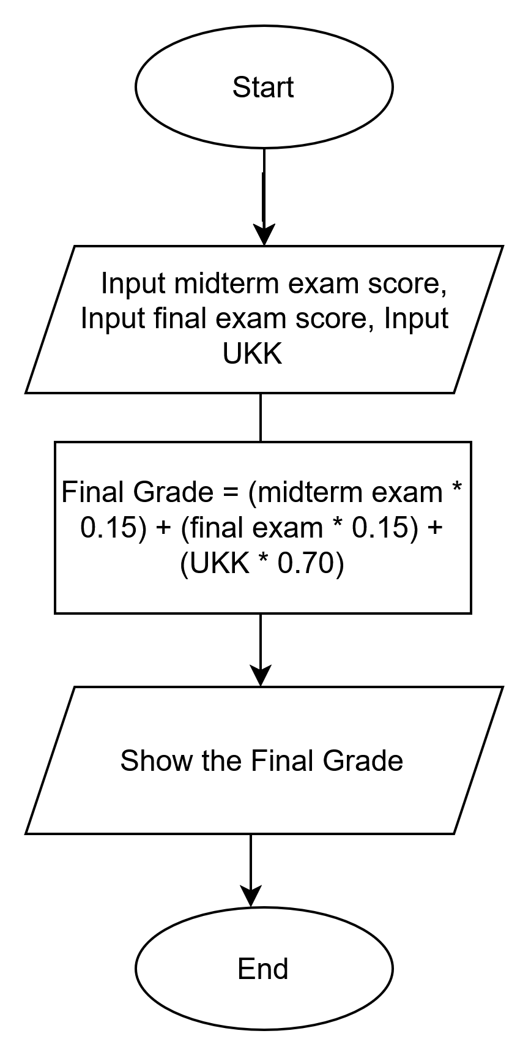
FLOWCHART: Gaji
